Solution: Dependent Drop-downs

In this lab, you will create dependent drop-downs for the Interaction Popup using dynamic typelist filters for the Interaction_Ext entity.

Requirements

This lab requires that you first complete labs from previous lessons including Creating Entities, Typelists, Editable List View Panels, and Create New Objects with Popups.

This lab requires that you use TrainingApp 8.0, Guidewire Studio 8.0, and a supported web browser. To view, edit, and delete various contacts, log in to TrainingApp as Alice Applegate. The default URL for TrainingApp is <http://localhost:8880/ab/ContactManager.do>. The login/password for Alice Applegate is aapplegate/gw.

1. Create dependent drop-down lists

Acme Insurance requires that there is a dependent relationship between the Channel Direction and Channel Type in the Interaction Popup. The following table describes the dependent relationship:

|  |  |
| --- | --- |
| Channel Direction | Channel Type |
| Inbound | Email  Fax  In Person  Other  Phone |
| Outbound | Email  Fax  Postal Mail |

For example, when a user selects the Outbound channel type, the channel drop-down list needs to show only the Email, Fax, and Postal Mail channels.

In addition, Acme Insurance requires that there is a dependent relationship between the Channel Type and the Interaction Reason in the Interaction Popup. The following table describes the dependent relationship:

|  |  |
| --- | --- |
| Channel Type | Interaction Reason |
| Email | Complaint  Other  Request |
| Phone | Complaint  Other  Request |
| Postal Mail | Courtesy Contact Other |
| Fax | Complaint Other  Request |
| In Person | Complaint Courtesy Contact Other  Request |
| Other | Other |

For example, when a user selects the Postal Mail channel type, the interaction reason drop-down list needs to show only the Courtesy Contact and Other interaction reasons.

In Part A of this exercise, you will first create the ChannelDirection_Ext.tti typelist. The typelist will contain two typekeys: Inbound and Outbound. In Part B of this exercise, you will modify the related typelists to create dynamic typelist filters. In Part C, you will then add the ChannelDirection typekey to the Interaction_Ext entity and add typekey keyfilters where needed. In Part D, you will modify the Interaction Popup and add an editable TypeKey input widget for the ChannelDirection typekey. In Part E, you will deploy your configuration changes and verify your configuration.

Part A

In Part A of this exercise, you will first create the ChannelDirection_Ext.tti typelist. The typelist will contain two typekeys: Inbound and Outbound.

Configuration

1. Open Guidewire Studio for TrainingApp
2. From Studio, if your server is not already running, start the server using Debug 'Server'.
3. Review the Debug console for errors and verify that the application is running in the Debug console.
4. Create the ChannelDirection_Ext typelist
5. ..

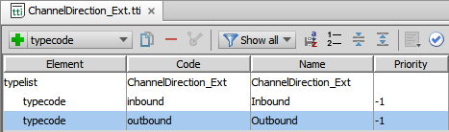

Part B

In Part B of this exercise, you will modify the related typelists to create dynamic typelist filters.

Configuration

1. Modify the typelists
2. Use the Typelist Editor to modify the dependent typelists according to Acme Insurance requirements.

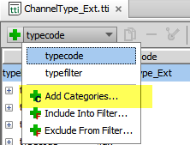

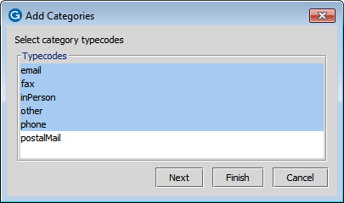

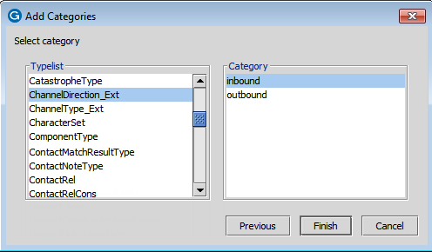

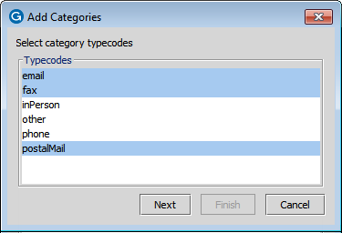

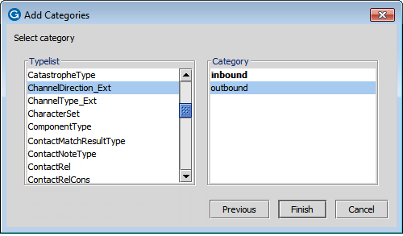

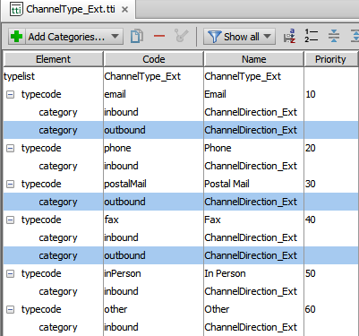

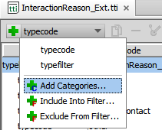

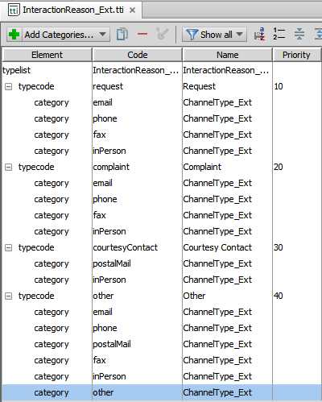

Part C

In Part C, you will then add the ChannelDirection typekey to the Interaction_Ext entity and add typekey key filters where needed.

Configuration

1. Modify the Interaction_Ext entity
2. Use the Entity Editor to modify the Interaction_Ext entity.
3. Add the ChannelDirection typekey for the ChannelDirection_Ext typelist.

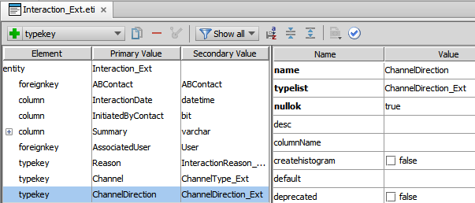

1. Where required, add typekey keyfilters.

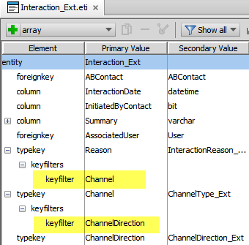

Part D

In Part D, you will modify the Interaction Popup and add an editable TypeKey input widget for the Channel Direction typelist.

Configuration

1. Modify the InteractionPopup PCF file
2. Above the Channel Type input widget, add an editable TypeKey input widget for the ChannelDirection typekey.  
   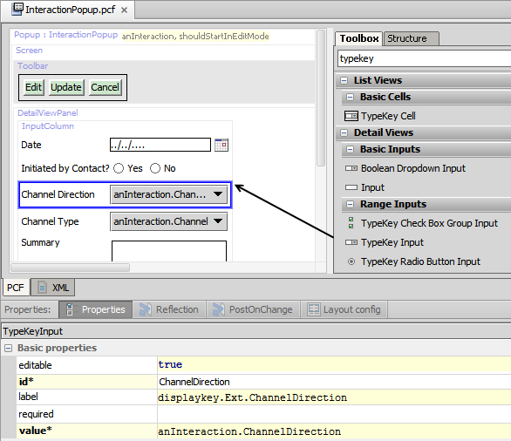

Part E

In Part E, you will deploy your configuration changes and verify your configuration.

Deployment

1. Deploy your changes
2. From studio, restart the server using Debug 'Server'.
3. If open, review the Messages Make window for compilation errors.
4. Review the Debug console for errors.
5. Verify that the application is running in the Debug console.

Verification

1. Log in to TrainingApp
2. Log in as Alice Applegate.
3. Create a new interaction for William Andy
4. Open the William Andy contact.
5. In the sidebar menu, click Interactions. Click Add.
6. Enter interaction details that verify the desired behavior of the dependent drop-down lists.
7. Click Update.

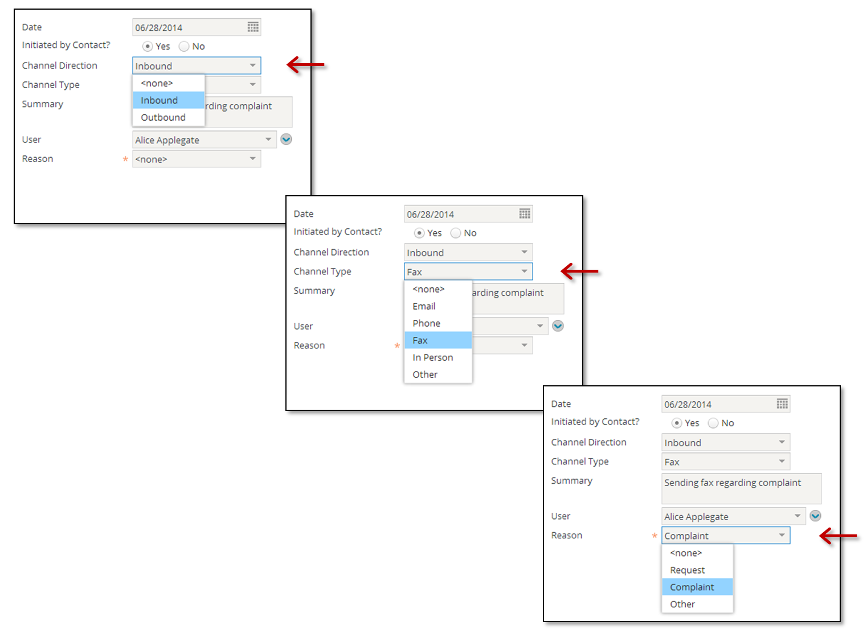

|  |  |
| --- | --- |
|  | Stop and ask your instructor to review your completed lab. |